(Option) Trim Crop

Write a function trim_crop_image which removes trim_size amount of pixels from each side of the image.

def trim_crop_image(original_img, trim_size):

"""

This function returns a new SimpleImage which is a trimmed and

cropped version of the original image by shaving trim_sz pixels

from each side (top, left, bottom, right) of the image. You may

assume trim_size is less than half the width of the image.

Inputs:

- original_img: The original image to process

- trim_size: The number of pixels to shave from each side

of the original image

Returns:

A new SimpleImage with trim_size pixels shaved off each

side of the original image

"""

For example, if we called trim crop on this picture of Karel, and removed trim_size = 30 pixels from all sides:

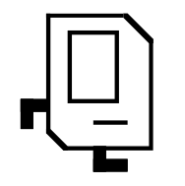

It would produce an image that looks something like this:

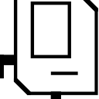

Note that the dimensions of this new image is smaller (both the width and the height have been reduced by 60 pixels).